Abstraction and Algorithms

Computer Science - Week 1  
Aug 20, 2022 - Version 0.0.2

Please make sure that all members of the group place their UD **email** AND **name** below. Unless your UD emails are included in this table, then you will not earn any points for this assignment when it is graded!

Choose roles following the [instructions here](https://blockpy.cis.udel.edu/assignments/reading/bakery_appendix_pogil).

You should work in groups of 3. If you cannot find 3 group members, then work in groups of 2.

| **Role** | **Name** | **Email** |
| --- | --- | --- |
| **Manager** |  |  |
| **Speaker** |  |  |
| **Recorder** |  |  |

# 1) Drawing Together

You and your group are going to play two rounds of a drawing game. The goal is to get a better understanding of how programmers must give clear, simple instructions to a computer (an “Algorithm”) to build a representation of something from the real world (an “Abstraction”).

This game is similar to the game Pictionary, where one player is given a secret word and must draw a picture of the word such that the other players guess the secret word. However, in our game, the player with the word (“The Programmer”) does not draw the picture but instead gives INSTRUCTIONS for how to draw a picture for the word. The other players (“The Computers”) each try to draw a picture based only on the instructions given by The Programmer. Then, each of the Computers tries to guess what the original secret word is, based on the images drawn.

The main twist is that The Programmer can only give instructions to draw rectangles, triangles, and circles. They cannot ask The Computers to draw any other shapes, and they definitely cannot say the secret word or give hints about what their secret word is. The Computer and the Programmer should avoid looking at anyone else’s drawing while they play, until all the instructions are given and the drawings are complete.

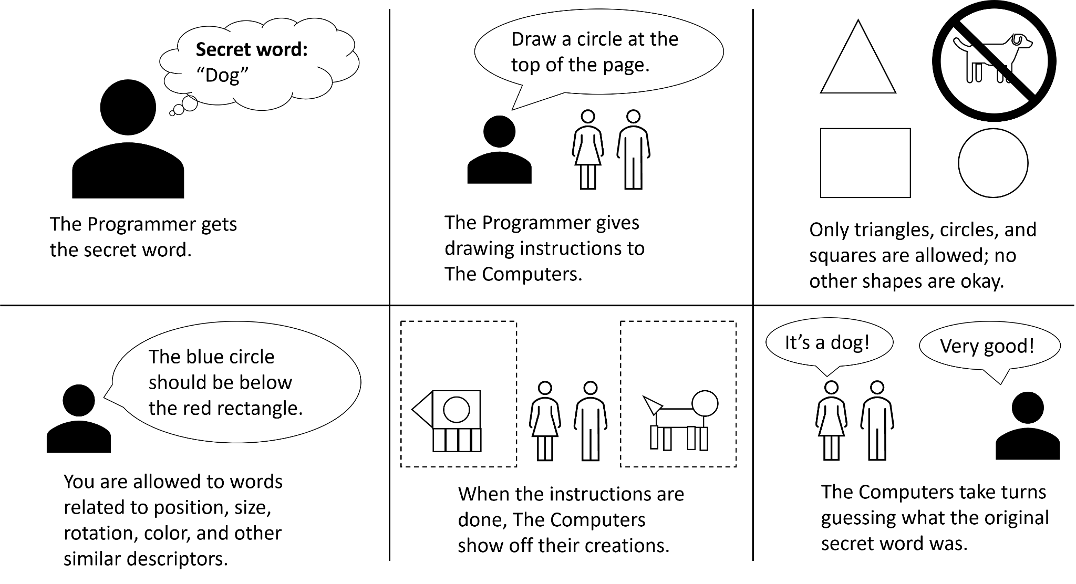

The Manager will be the first Programmer, the Speaker will be the First Computer, and the Recorder will be the Second Computer. The winner of the first round becomes the Programmer of the second round.

The Computers will draw their images using the two boxes below, each Computer having their own separate image. Each Computer can double click their own image to open the picture editor. Then, they just delete the existing box and start adding their own shapes. Alternatively, you can use your preferred image editor as long as you can draw rectangles, circles, and triangles.

The Programmer can get their random word from a word generator site like this one:

<https://thegamegal.com/word-generator/>

**1. Round 1**

Who are the players of Round 1?

| **Programmer** |  |
| --- | --- |
| **First Computer** |  |
| **Second Computer** |  |

|  |
| --- |
|  |

2. Who was the winner? Write their name in the box below:

|  |
| --- |

**3. Round 2**

Who are the players of Round 2?

| **Programmer** |  |
| --- | --- |
| **First Computer** |  |
| **Second Computer** |  |

|  |
| --- |
|  |

4. Who was the winner? Write their name in the box below:

|  |
| --- |

# 2) Analyze the Game

5. What made giving and understanding the instructions difficult?

|  |
| --- |

6. Abstractions are representations of information from the real world in a computer, with details necessarily being lost as part of the process of creating the abstraction. What was the abstraction in this game? What were the things from the real world that were being abstracted?

| Abstraction: |
| --- |
| Real world things: |

7. Based on your understanding of the material so far, how are the algorithms and abstractions from this assignment similar and different to the algorithms and abstractions that computers regularly use?

| Similar: |
| --- |
| Different: |

# 3) Reflect and Review

Discuss among yourselves: what did you learn from this activity? What was surprising or interesting? If you didn’t learn anything, what do you think we were trying to teach you? How could this activity be improved?

|  |
| --- |
|  |
|  |

# Final Submission

When your team is happy with your answers for all the questions, download this file as a Microsoft Word Document (docx) and upload the file to the appropriate assignment on Canvas.

Only one member of your team needs to submit the file on Canvas.

Make absolutely sure that everyone’s UD emails are included in the box at the top, or they will not earn points for this assignment!